# CloudSim Essentials: Required Software

JDK 1.6 or above <http://tinyurl.com/JNU-JAVA> Eclipse 4.2 or above <http://tinyurl.com/JNU-Eclipse>

Alternatively, NetBeans: https://netbeans.org/downloads Up & Running with cloudsim guide: https://goo.gl/TPL7Zh

Cloudsim-Directory structure

cloudsim/ -- top level CloudSim directory docs/ -- CloudSim API Documentation examples/ -- CloudSim examples

jars/ -- CloudSim jar archives sources/ -- CloudSim source code

# Procedure: Installation Steps

* Download CloudSim Archives
* Visit CloudSim Releases : https://github.com/Cloudslab/cloudsim/releases
* Download CloudSim 4 archives.
* Extract Archive
* Extract the downloaded archive.
* Verify Jar Files
* Confirm the presence of the following files in the "jars" folder:
  + cloudsim-4.0.jar
  + cloudsim-examples.jar
* Setting Up Eclipse Project
* Create a new Java Project in Eclipse IDE.

* 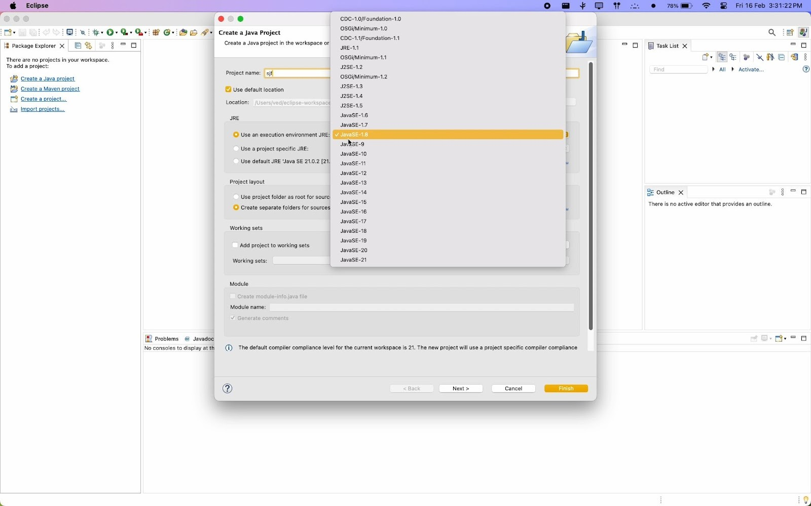Create a New Package
* 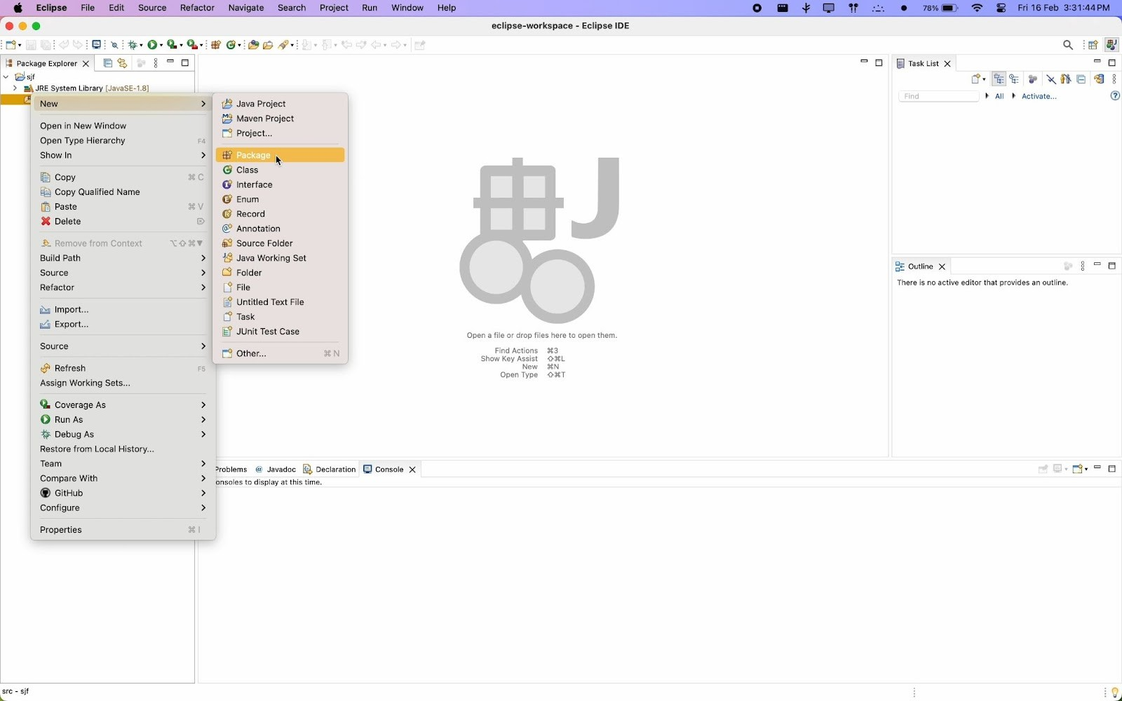In the "src" directory, create a new package for your project.

* Copy the code files (constants, Data Center Creator, Data Center Broker,

Matrix Generator, SJF scheduler) from

https://github.com/suyash-more/Cloud-Computing-Projects/tree/master/Sch eduling-Algorithm-in-CloudSim/src

* Ensure that the package name in each file matches the previously created package.

# Procedure: Eclipse Project Setup

* Build Path Configuration
* Right-click on the project root.
* Select "Build Path" from the dropdown menu.
* Configure Build Path
* A screenshot of a computer

  Description automatically generatedA computer screen with a white screen

  Description automatically generatedFrom the extended dropdown, select "Configure Build Path."
* Add External JARs
* In the Libraries section, click "Add External JARs."
* Navigate to the "jars" directory of the CloudSim archive.
* Include "cloudsim-4.0.jar" and "cloudsim-examples.jar" in the project.

# Procedure: Execution of Code

* Running the Project in Eclipse:
* Right-Click on the Project
* Right-click on the project in the Eclipse IDE.

▪

* Run as Java Application
* Select "Run as Java Application" from the extended dropdown.
* A computer screen shot of a computer

  Description automatically generated
* A computer screen with a white screen

  Description automatically generated
* View the Result

The result will be displayed on the console

# Output:

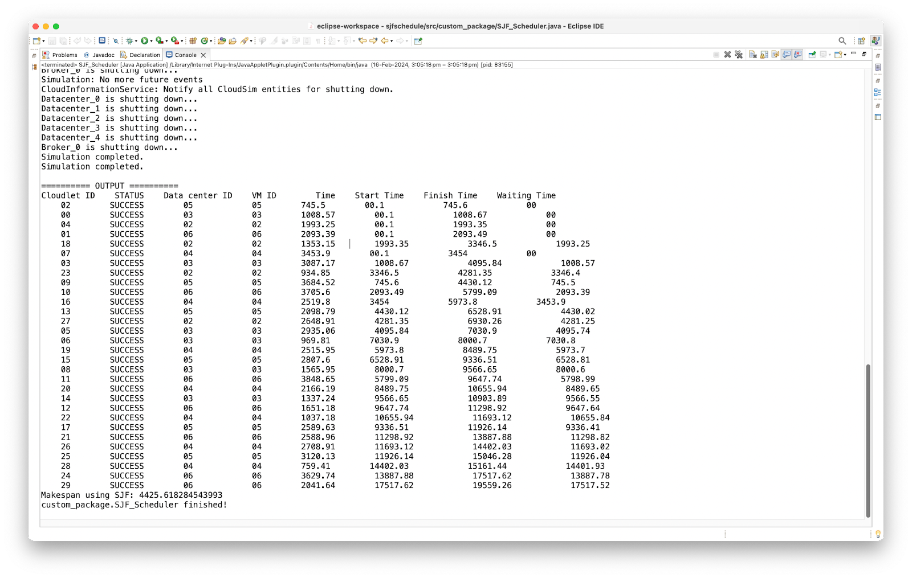**Fig:** Screenshot of output

# Conclusion:

Thus, in this assignment the cloudsim using Eclipse Environment is configured and a different scheduling algorithm is used successfully.